**Environmental & Sustainability Considerations**

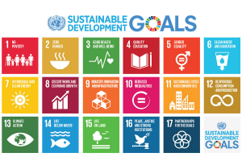

In 2018 UCD took a strategic decision to map the universities actions in education, research, governance and engagement against the United Nations (UN) Sustainable Development Goals. UCD also recognises the important role it has to play as a leader in the global challenges of sustainable development and climate change, not only in research and teaching but also in the operation and development of its campuses. The University seeks to attain a sustainable, healthy and living campus and as such endeavours to manage the campus in a way that considers energy and water usage, waste management, sustainable commuting and biodiversity in all of its activities where relevant.

This therefore impacts on the decisions taken when procuring goods, services and equipment. Environmental and sustainability considerations must be taken into account when drawing up Specifications and developing Award Criteria in order to have an informed decision on the Total Cost of Ownership of a Product or Service. . UCD is certified to Energy Management System, ISO50001 and therefore as an organisation we are required to include criteria on life cycle energy costs where appropriate in our tender documentation.

The appropriateness and extent of environmental and sustainability factors will vary from project to project.

Comprehensive guidance on the use of environmental clauses is set out in:

* Green Tenders - An Action Plan on Green Public Procurement, published in 2012 by the Department of Environment, Community and Local Government and the Department of Public Expenditure and Reform, and
* Green Procurement Guidance for the Public Sector published in 2014 by the Environmental Protection Agency

Both of these documents are available under the Useful Information and Resources webpage.

Another useful resources can be found on https://www.interregeurope.eu/gpp4growth/

Eight priority areas of procurement activity are identified in these guidance documents as most suitable for inclusion of environmental measures including;

* construction;
* energy;
* transport;
* food and catering services;
* cleaning products and services;
* paper;
* clothing and textiles;
* information and communications technology.

The Triple E Register available on the SEAI website contains a comprehensive list of products approved as being energy efficient. Additional guidance is available for those interested in buying goods and services with a lower environmental impact in “Buying Green!” which is the EU Commission’s main guidance document in this area.

In 2019 the Department of Public Expenditure & Reform issued Circular 20/2019 which is promoting the use of environmental and social considerations in public procurement and which can be accessed under the Useful Information and Resources webpage. Set out below are factors that need to be considered at the various stages of the procurement process.

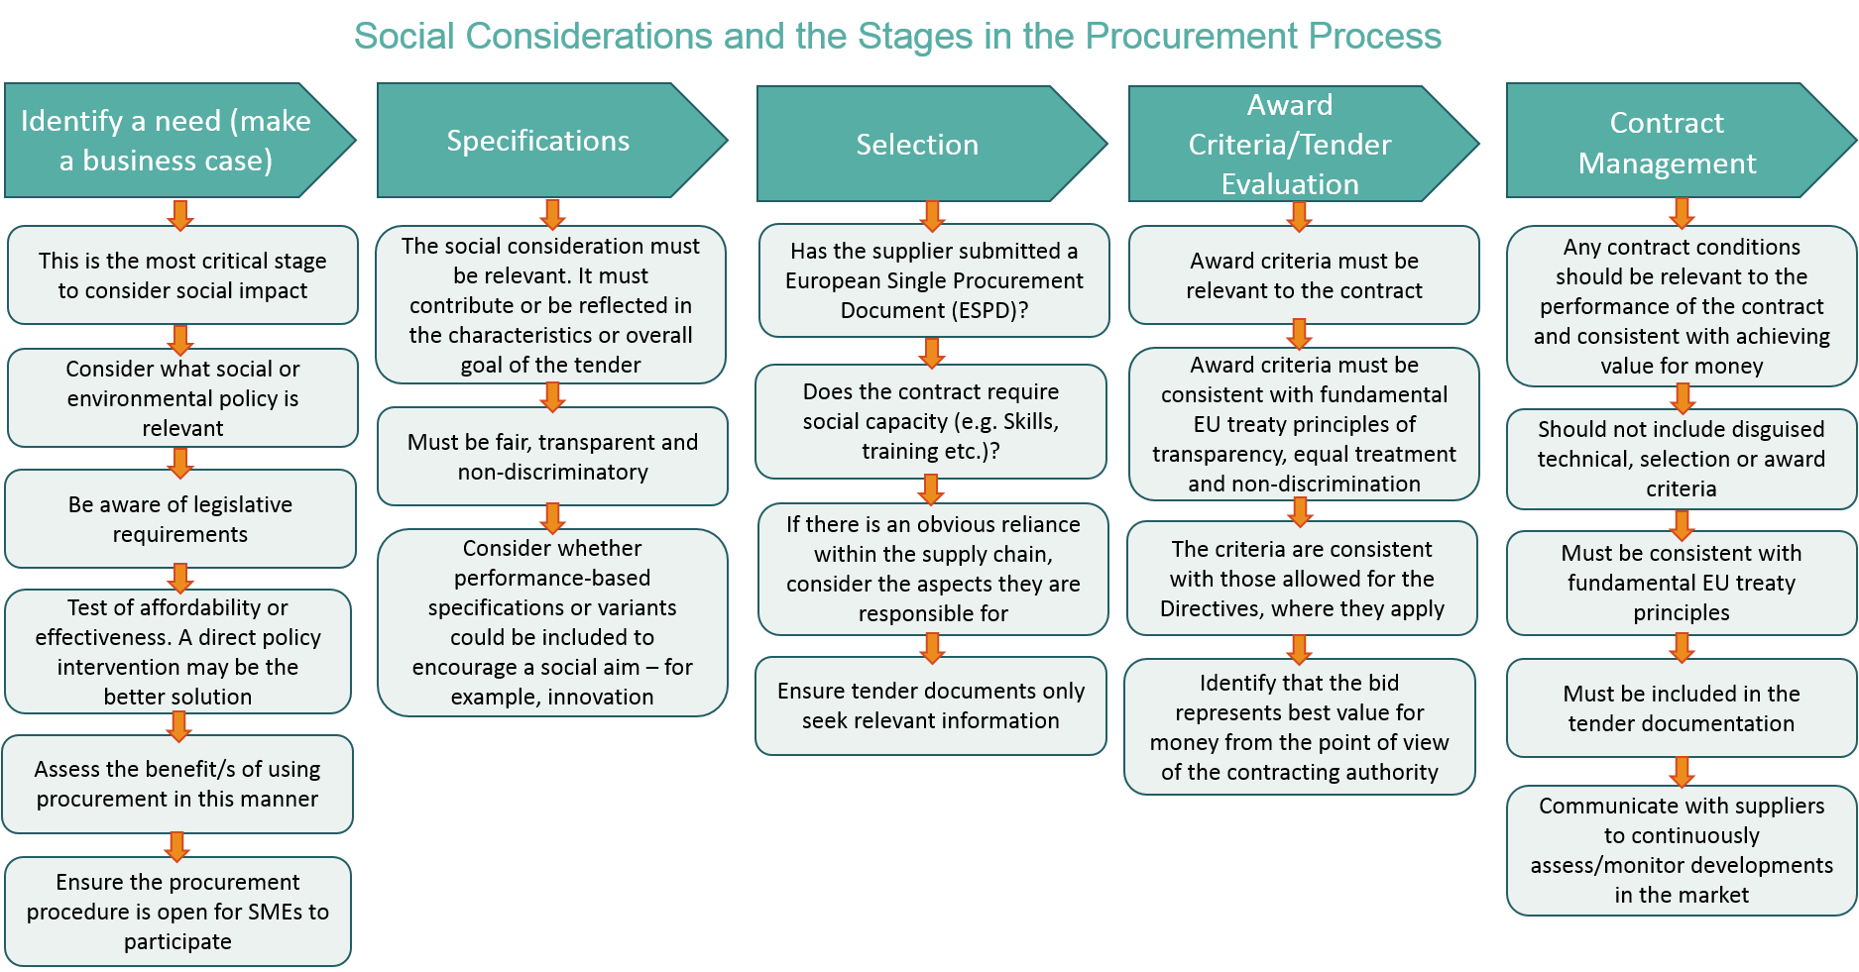

Please contact the Procurement, Contracts and Buying Function for further information and advice.